Signing for Devices in One to One Plus

- Go to this link to access One to One Plus. (https://1to1plus.com/login/Hoke_NC)
- Sign in using Google using your Hoke County Schools account.
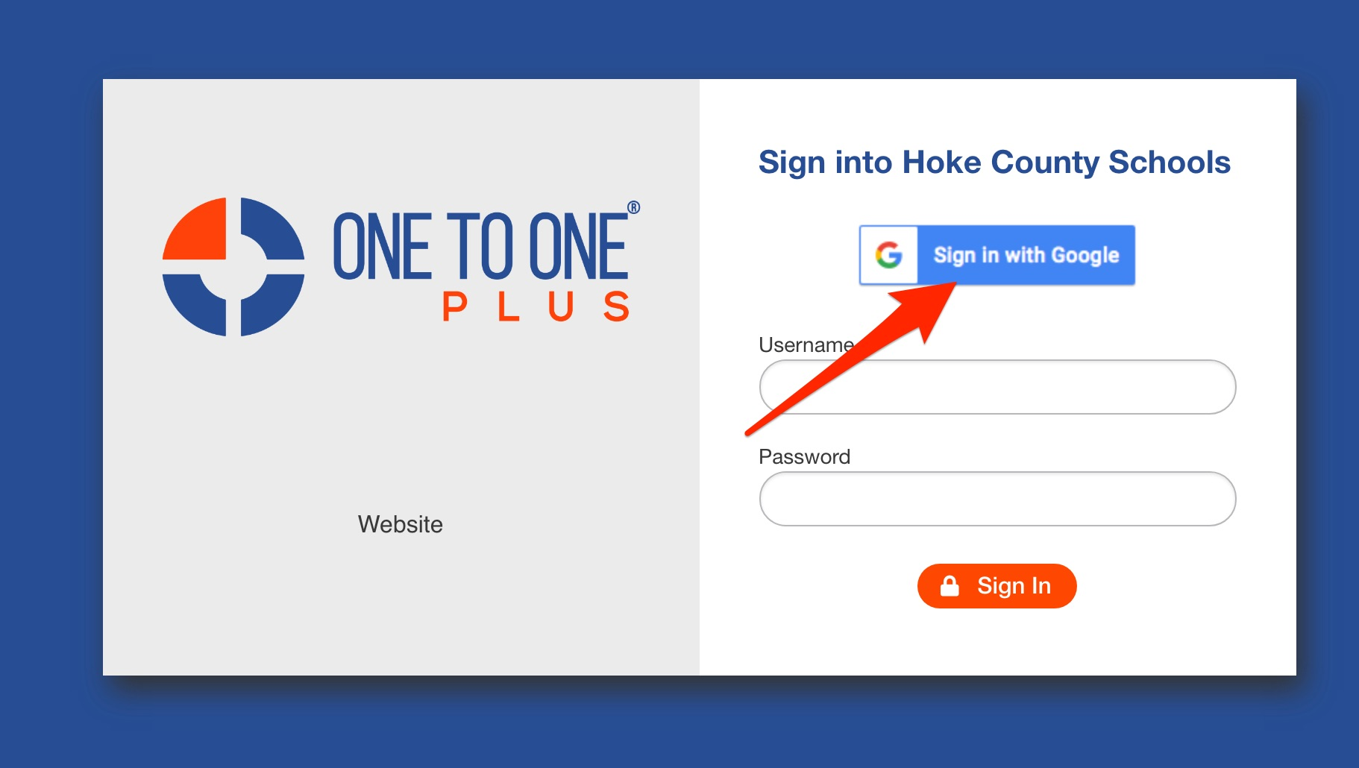

- You will see this screen when you first log in. Go to your name and click for the drop down menu.
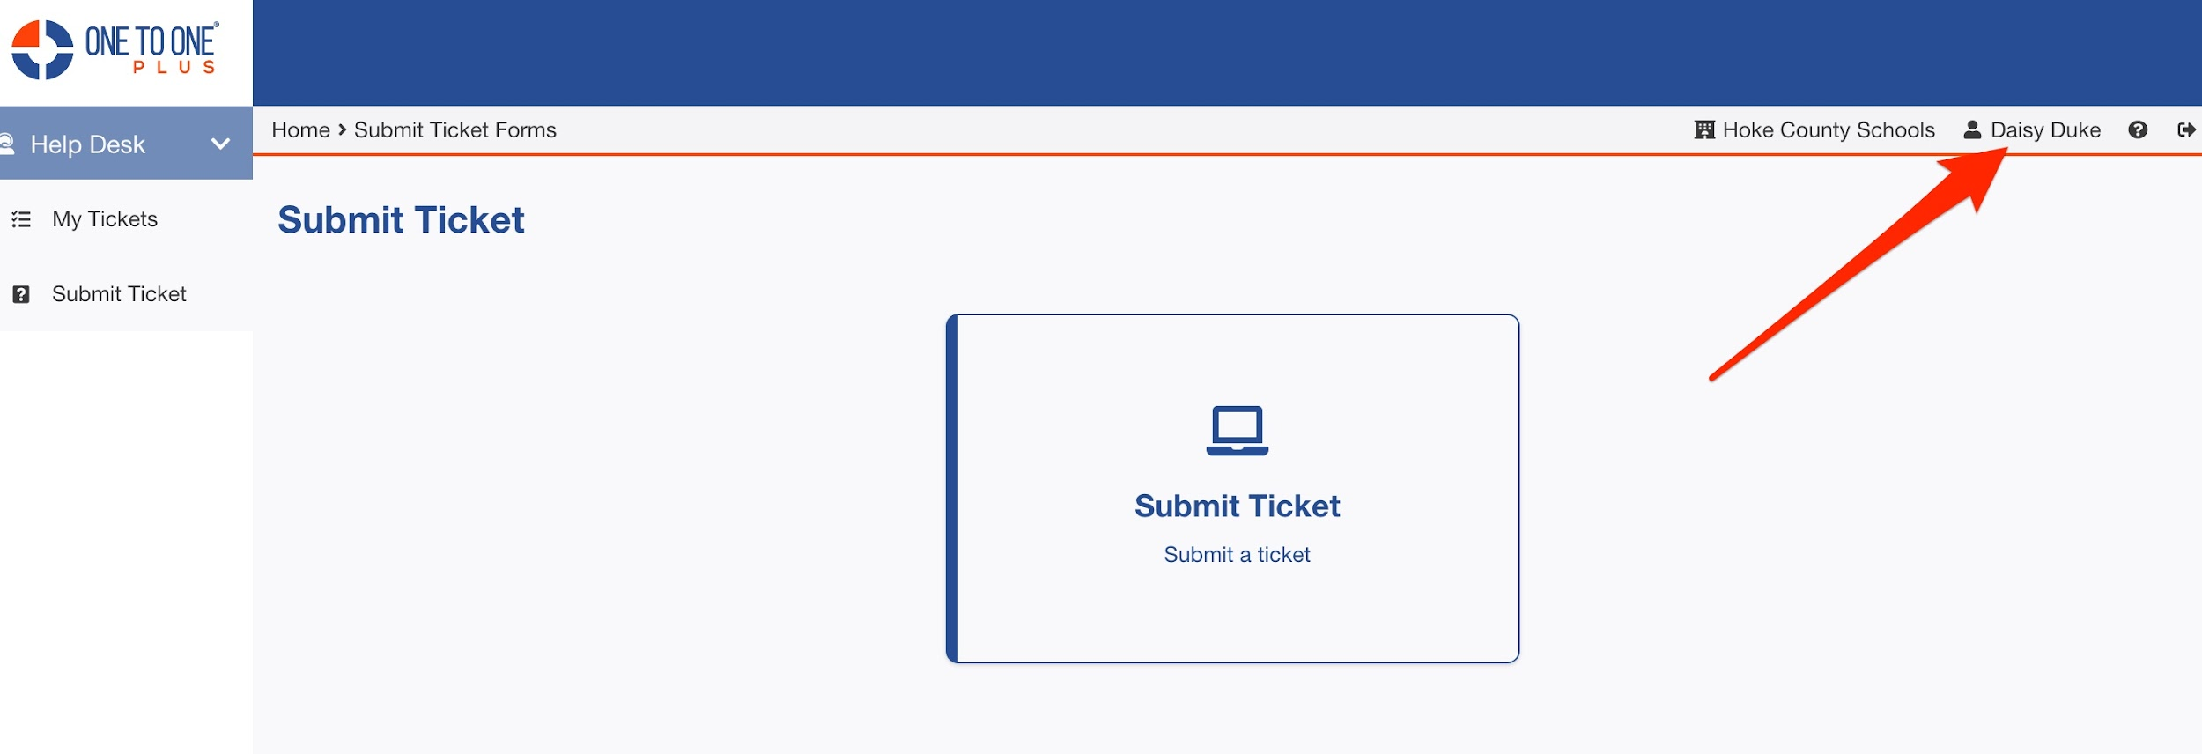

- Find the section labeled Policies. Find Hoke County Schools’ Technology Honor Code. Click on SIGN.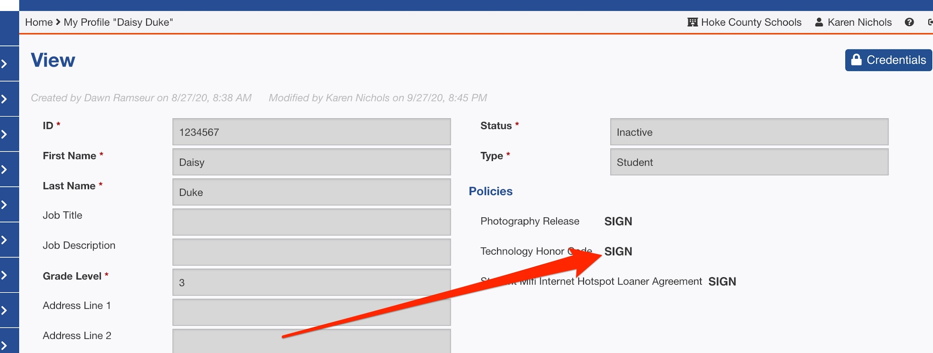

- Read the information in the agreement.
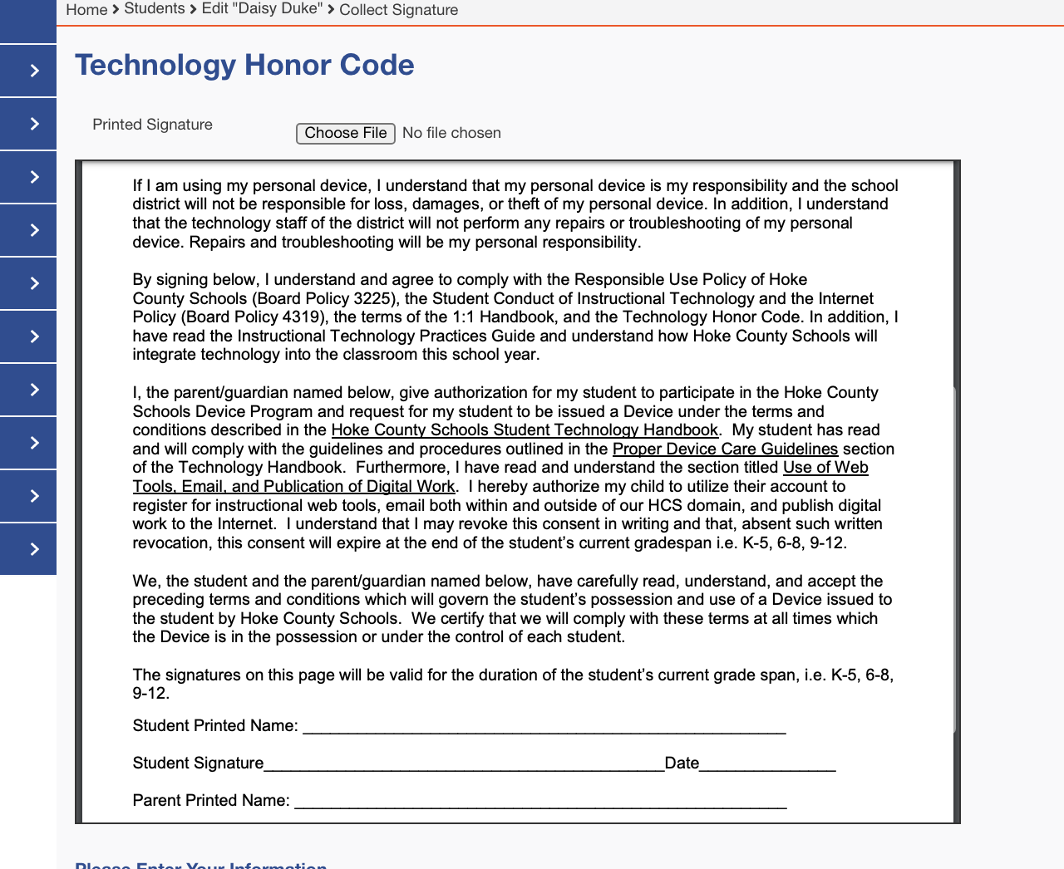

- Complete the information:
  - Complete the PARENT information in the boxes.
  - Check ALL boxes.
  - Sign in the box.
  - Click ACCEPT.
